PRINTERS

A printer is an external hardware output device responsible for taking electronic data stored on a computer or computing device and generating a hard copy of that data. Printers are one of the most commonly used peripherals on computers and are commonly used to print texts and photos.

History of the printer
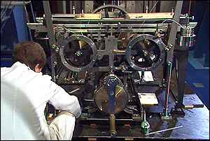
The world's first computer printer was a 19th-century mechanically driven apparatus invented by Charles Babbage.. This system used a set of metal rods with characters printed on them. They were carried on a roll of paper against the rods to print the characters. The first commercial printers generally used mechanisms from electric typewriters and Teletype machines, which operated in a similar mode. The demand for higher speed led to the development of new systems specifically for computer use.
The introduction of the low-cost laser printer in 1984 with the first HP LaserJet, and the addition of PostScript in next year's by Apple LaserWriter, meaned a revolution in printing known as desktop publishing. Laser printers use PostScript – a mixed text and graphics, as well as dot-matrix printers, but at higher quality levels.
Today, traditional printers are being used more for special purposes, like printing photographs or artwork, and are no longer a must-have peripheral.

Types of printers
Below is a list of all the different types of computer printers. Today, the most common printers used with a computer are Inkjet and Laser printers.
- 3D printer
- All-in-one (AIO) printer
- Dot Matrix printer
- Inkjet printer
- Laser printer
- LED printer
- Multifunction printer (MFP)
- Plotter
- Thermal printer

Printer interfaces
There are different interfaces or ways how a printer can be connected to the computer. Today, the most common is a connection by a cable when the printer is connected to a computer by using a USB or by a Wi-Fi connection. Below is a full list of cables and interfaces used to connect a computer to a printer.
- Cat5 (RJ 45)
- Firewire
- MPP-1150
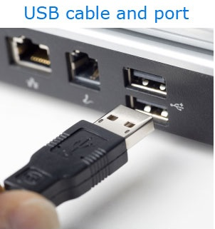
- Parallel port
- SCSI
- Serial port
- USB
- Wi-Fi

Inkjet printing
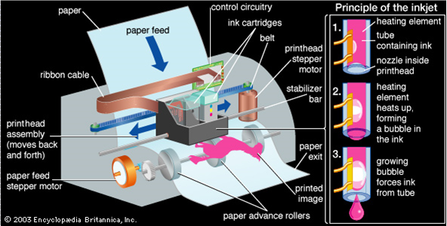
Inkjet printing is a type of computer printing that recreates a digital image by propelling droplets of ink onto paper, plastic, or other substance. Inkjet printers are the most commonly used types of printers, and range from small inexpensive consumer models to expensive professional machines.
The concept of inkjet printing originated in the 20th century, and the technology was first extensively developed in the early 1950s. In the late 1970s inkjet printers could reproduce digital images generated by computers. The main producers were Epson, Hewlett-Packard (HP), Brother and Canon.

There are two main technologies used in contemporary inkjet printers:
- Bubble jet
- Piezoelectric jet

Laser printing
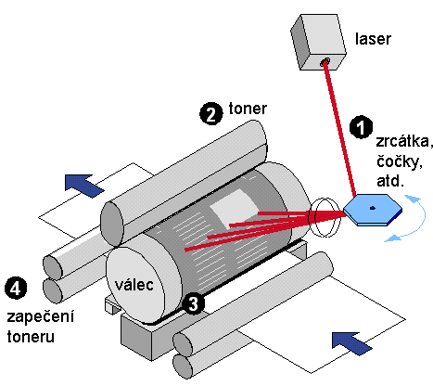
Laser printing is an electrostatic digital printing process. It produces high-quality text and graphics (and moderate-quality photographs) by repeatedly passing a laser beam back and forth over a negatively charged cylinder called a "drum" to define a differentially charged image. The drum collects electrically charged powdered ink (toner), and transfers the image onto paper, which is then heated in order to permanently fuse the text and/or pictures. Laser printers employ a xerographic printing process as well as digital photocopiers and multifunction/all-in-one printers. Over the decades, quality and speed have increased, the price has fallen, and the high-tech printing devices are now common.

Plotter
The plotter is a computer printer for printing vector graphics. In the past, plotters were used in branches such as computer design, though they have generally been replaced with wide-format conventional printers. The plotter gives a hard copy of the output. It draws pictures on paper using a pen. Plotters are used to print designs of ships and machines, plans for buildings and so on.
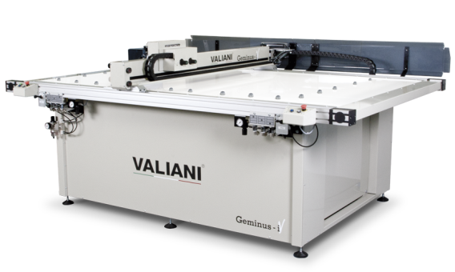

Thermal printing
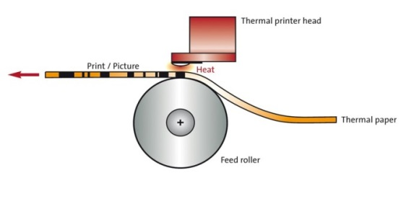
Thermal printing (or direct thermal printing) is a digital printing process which produces a printed image by heating and passing over the heat-sensitive foil or thermal paper when the paper passes over the thermal print head. The coating turns black in the areas where it is heated, producing an image. Two-colour direct thermal printers can

print both black and an additional colour (often red) by applying heat at two different temperatures. Thermal transfer printing is a very different method that uses a heat-sensitive foil instead of heat-sensitive paper but uses similar thermal print heads.
Multifunction printer
E-mail An MFP (Multi-Function Printer), all-in-one (AIO), or Multifunction Device (MFD), is an office machine which incorporates the functionality of multiple devices in one. They are used in a home or small business setting (the SOHO market segment) or in a large-office setting to provide centralized document management/distribution/production. A typical MFP may act as a combination of some or all of the following devices:
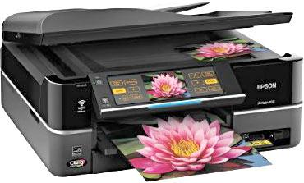
- Fax
- Photocopier
- Printer
- Scanner

